Q1) Solve any five : [5×2=10]
a) What is hypothesis.
b) What is test of validity?
c) Explain semantic scale.
d) Define Research design.
e) Write the steps of research.
f) What are the types of probability sampling?
g) Write the sources of secondary data.
h) Write the difference between questionnaire and schedules?

Q2) Solve any two : [2×5=10]
a) Which are the most commonly used measurement scales. Explain nomial scale in detail.
b) What is sampling? What are the essential of a good sample?
c) What are the requirements of a good questionnaire? Give reasons

Q3) Solve any one : [1×10=10]
a) Draft a questionnaire to determine the attitude of buyers towards online shopping experience. b) Draft a questionnaire to find online social sites top 10 business practices.

Q4) Solve any one : [1×10=10]
a) List and scrutinize any four probability sampling methods with their relative merits and drawbacks.
b) The frequency distribution is given in the table. Construct a histogram and determine the mode.
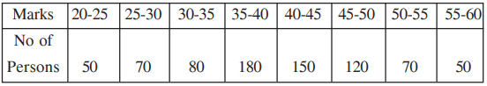

Q5) Solve any one: [1×10=10]
a) Design a research proposal status how psychology can help improve education.
b) Develop a research proposal to examine the effects of Work-life Balance Policies on Employee Satisfaction and Retention.

